**Election Analysis 2024 Lok-Sabha**

The 2024 Indian parliamentary decisions saw huge discretionary elements across different states and electorates. This report provides a detailed analysis focusing on key aspects such as voter turnout, margin of victory (MoV), coalition dynamics, and other critical factors influencing electoral outcomes. Citizen turnout shifted fundamentally in the 2024 decisions, averaging 65% across the voting public. This measurement highlights the shifting degrees of metro commitment and political interest noticed all through the constituent interaction, reflecting powerful metropolitan contributions and fluctuating political help across supporters.

In the 2024 elections, despite not securing an outright majority, the Bharatiya Janata Party (BJP), supported by the National Democratic Alliance (NDA), which included other allied parties and independent candidates, garnered enough seats (293 in total) to form the government. The Margin Of Victory(MoV) played a pivotal role in determining electoral outcomes, highlighting competitive races and strategic voting patterns. For instance, the Bharatiya Janata Party (BJP) led with an average MoV of 192,809.77, illustrating its strong electoral performance across contested constituencies. Other parties such as Janasena Party (JnP), Telugu Desam (TDP), and Indian National Congress (INC) also showed significant MoV metrics, indicating localized electoral strengths and voter preferences.

**Average MoV Vs Parties**

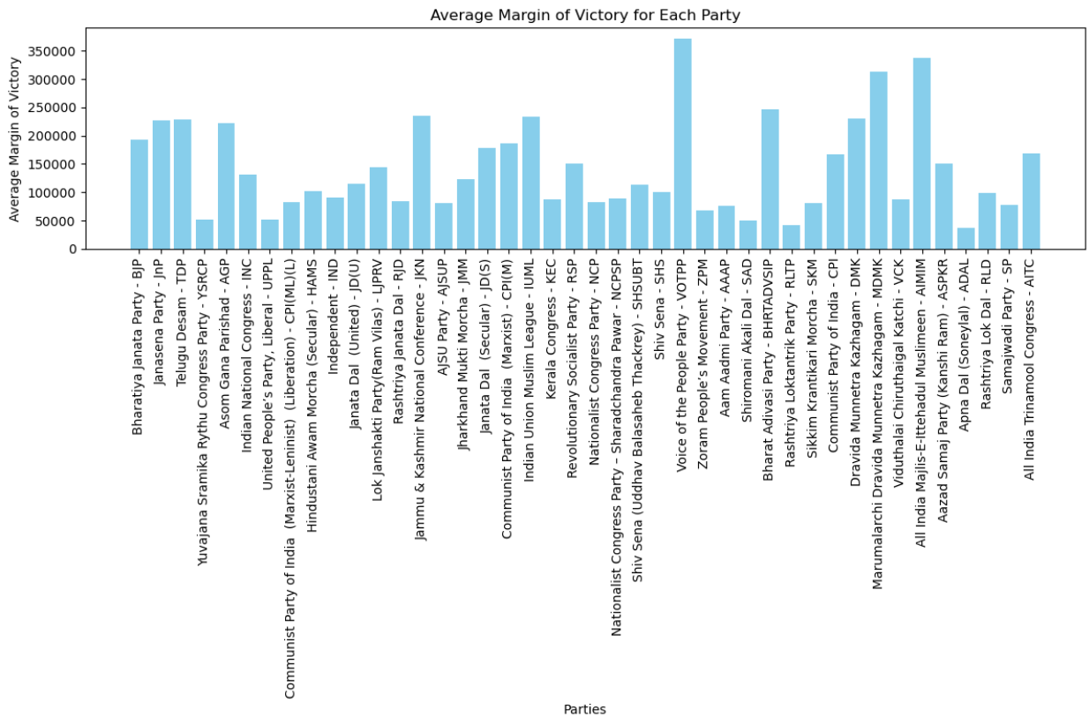

The 2024 Indian parliamentary elections witnessed varied levels of party dominance across different states and union territories. In Andhra Pradesh, the Telugu Desam Party (TDP) drove with 64% of the seats, trailed by a different conveyance among Bharatiya Janata Party (BJP) at 12%, Janasena Party (JnP) at 8%, and Yuvajana Sramika Rythu Congress Party (YSRCP) at 16%. Assam saw Bharatiya Janata Party (BJP) arise predominant with 64.29%, with Asom Gana Parishad (AGP) and Indian Public Congress (INC) getting 7.14% and 21.43%, separately. In Bihar, both Bharatiya Janata Party (BJP) and Janata Dal (Joined together) (JD(U)) gathered 30% of the seats, with more modest offers contributed by different gatherings. Point by point breakdowns for Chandigarh are forthcoming, while in West Bengal, All India Trinamool Congress (AITC) overwhelmed with 69.05%, trailed by Bharatiya Janata Party (BJP) at 28.57% and Indian Public Congress (INC) at 2.38%.

Coalitions enhanced electoral viability by pooling resources, coordinating campaign efforts, and broadening their appeal to a diverse voter base. This approach proved successful in securing victories in closely contested constituencies where combined strength outweighed individual party capabilities.

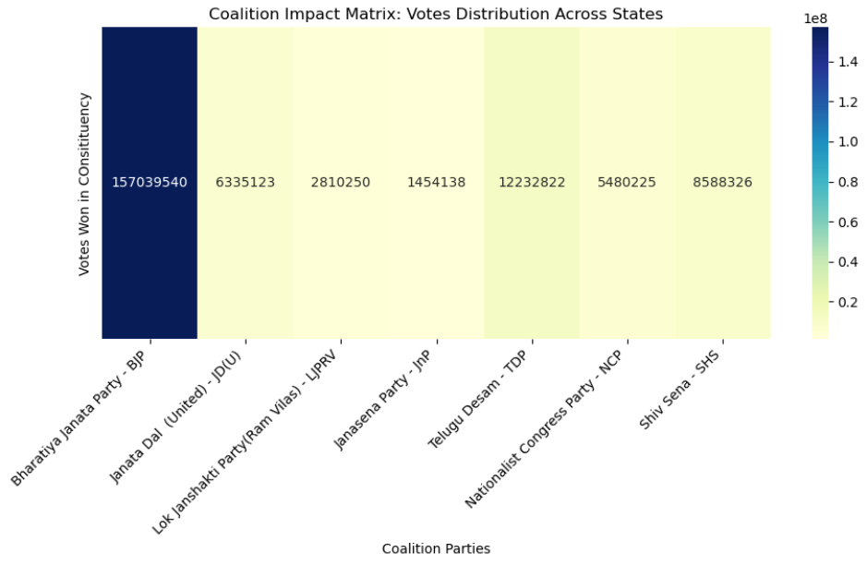

In Uttar Pradesh, the Bharatiya Janata Party (BJP) encountered a remarkable change in electing fortunes between the 2019 and 2024 parliamentary decisions. In 2019, BJP secured over 60 seats, reflecting a strong electoral mandate across the state. However, in the 2024 elections, BJP's seat tally decreased to 33 seats, indicating a significant reduction in electoral support compared to the previous election cycle. Changes in nearby administration, financial circumstances, and local area discernments might have impacted citizen conduct and party inclinations.

The 2024 Indian parliamentary decisions gave significant experiences into the advancing idea of political rivalry and vote-based administration in India. Citizen turnout, alliance elements, party predominance, and edge of triumph arose as critical variables impacting appointive results across different supporters. This report highlights the basic job of information driven examination in understanding constituent patterns, illuminating key navigation, and cultivating informed public talk on equitable cycles and administration.